Title: | <Project Name>  SW Component < XXXXXXX >

History
Issue status  (Index) | Maturity/Date  (draft/invalid/valid)  (dd-mmm-yyyy) | Author  Department | Check/Release  Department | Description
1.0 | Draft  04-0ct-09 | Miguel Garcia | Miguel Garcia | Creation of the document

Table of Contents
1 Purpose 3
2 Definitions and abbreviations 3
3 Realization constraints and targets 3
4 SW Conceptual design 3
5 SW Component internal breakdown 4
5.1 Functional Decomposition 4
5.2 Function <Type> <function name> (type par 1, .., type par n) 5
5.3 Function <Type> <function name> (type par 1, .., type par n) 5

Purpose
This document has been created as a simulation of a window lifter with propose that we learn to fill and create the detailed design from requirements.

Definitions and abbreviations
Definitions
PIT ------------------------------  0  64000000  2000  31999  GPIO ---------------------------  34  35  36  37  38  39  40  41  42  44  46  47  64  65  66  0  1  2  0  1  0  1  SIU.GPDO[channel].BPDO =1  SIU.GPDO[channel].BPDO =0  SIU.GPDO[channel].BPDO ^=1  SIU.GPDO[channel].B.PDO  !SIU.GPDI[channel].R  SIU.GPDI[channel].R  Dummy -------------------------------------  enum { NULO, AUTO, MANUAL, PINCH }  struct { const T_UBYTE , T_UBYTE, T_UWORD }  struct { T_UBYTE, T_UBYTE } |  | ----------------------------------------------------------  PIT_CHANNEL_0  PIT_DEVICE_FREQUENCY  PIT_CHANNEL_TARGET_FREQUENCY  PIT_CHANNEL_VALUE  ---------------------------------------------------------  LED0  LED1  LED2  LED3  LED4  LED5  LED6  LED7  LED8  LED9  LED_GREEN  LED_BLUE  BUTTON_UP  BUTTON_DOWN  BUTTON_ANTIPINCH  UP  DOWN  ANTIPINCH  GPIO_INPUT  GPIO_OUTPUT  GPIO_OPEN_DRAIN_DISABLE  GPIO_OPEN_DRAIN_ENABLE  LED_ON( channel )  LED_OFF( channel )  LED_TOGLE( channel )  STATUS_LED( channel )  HIGH( channel )  LOW( channel )  --------------------------------------------------------------  T_WL_STATUS  T_BUTTONSTRUCT  T_LEDSTRUCT

Abbreviations
//Only SW Component specific abbreviations.
References
N° | Document name | Reference
1  2  3  4 | SW C Code Review  Window lifter requirements  Traceability Matrix Template  Test Plan

Realization constraints and targets

Simulate a window lifter module responsible to control the window movement.
The button must have a time validation to consider a valid button press.
The window lifter module has to have two behaviors automatic and manual.
Integrate the anti-pinch functionality that prevents accidents between window and some human body parts like arms, hands and head.

SW Conceptual design
To make a conceptual design identify the product functions and the programs parts needed to produce them.
- Identifie all relevant parts in a system or sub-system.
- Define which parts are inside & outside the system boundary
- Define de interfaces between these parts, but also interfaces with neighboring systems and environment.

SW Component internal breakdown
For complex SW Components, the designer may define SW Subcomponents. Please consider also the work step "Deal with complexity" provided by the method for Detailed SW Design.
Note: SW Subcomponents are synonymous with the previous used term "Module"
Mapping to the file structure:
- Non complex SW Components should be represented by one object file.
- For complex SW Components each SW Subcomponent should be represented by one object file.
<Subcomponent decomposition if applicable>

Functional Decomposition
Overview of functions and their dependencies shown by a Static Function Tree
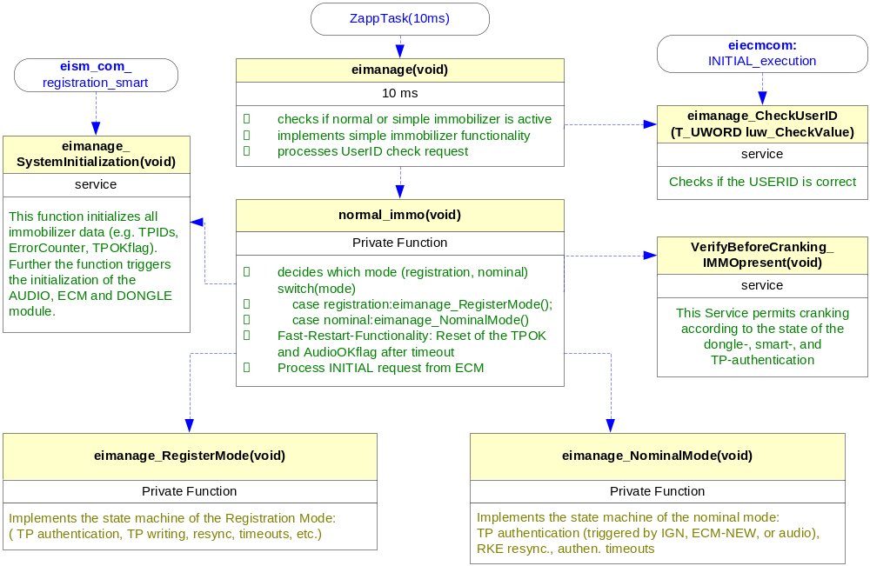
Function Description and Dynamic Behavior
Provide detailed static and dynamic description of all functions of the SW Component.
Functions which are defined in other SW Components shall only be referenced in the external interface description!
The signature description shall be done inside the function header in the source code.
For each function, the following section should be copied

Function <Type> <function name> (type par 1, .., type par n)

Description | Brief description of the function behavior and useful remarks
Parameter 1  <input| output| inout> | Give an explanation if the parameter shall be checked by the user, or if a check is implemented in the function here
Parameter 2..n
Return Value
Precondition | e.g. Function can only be called in a certain state, SW component is initialized  Relation between input parameters where applicable (Input for Module Test)
Post condition | e.g. specific State change e.g. car is locked, EEPROM Values written,  Relation between output parameters where applicable
Error Conditions

Dynamic Behavior
State Chart¹, Flow Chart¹
¹ Preferred
In this document, the dynamic behavior shall be designed on an abstract level showing the principle workflow of a function. Do not show the detailed implementation to ensure that the design description can be maintained with a reasonable effort. The target is not to show the complete detailed implementation 1:1.
The detailed design shall reflect in detail what a function is doing from a black box view. The internal details are useful on an abstract, but not very detailed level.
If the function is not complex a short textual description might be sufficient and a graphical description is not needed.
Symbol and function names shall be self explaining.
The link to the implementation may be provided by using the same names as in the design or by a comment showing the full name followed by the declaration showing the implementation.

Function void dummy_500us(void)

Description | This function is executed every 500us, is the main function of the code, this function controls the flow of calls of all the others functions
Parameter 1 | void
Return Value | void
Precondition
Post condition
Error Conditions

Dynamic Behavior

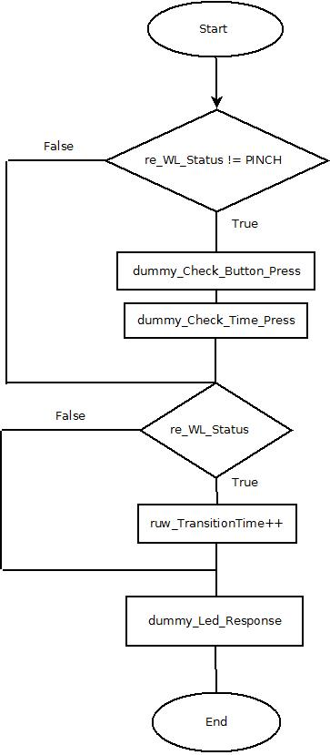

Function void dummy_Init_endlessloop(void)

Description | This function initialize all the struct and typedef and use an endless loop to ensure that the microcontroller does not stop
Parameter 1 | void
Return Value | void
Precondition
Post condition
Error Conditions

This function Initialize rps_ButtonPtr, rps_LedPtr, ruw_TransitionTime and re_WL_Status.

Function void dummy_Check_Button_Press(void)

Description | This function is responsible for monitoring inputs and validates whether a button is pressed if multiple buttons are pressed or not pressed any, and when it is valid increment the count of the button.
Parameter 1 | Void
Return Value | Void
Precondition | re_WL_Status must be different of PINCH
Post condition | Positions the pointer rps_ButtonPtr in one of the elements of the table
Error Conditions

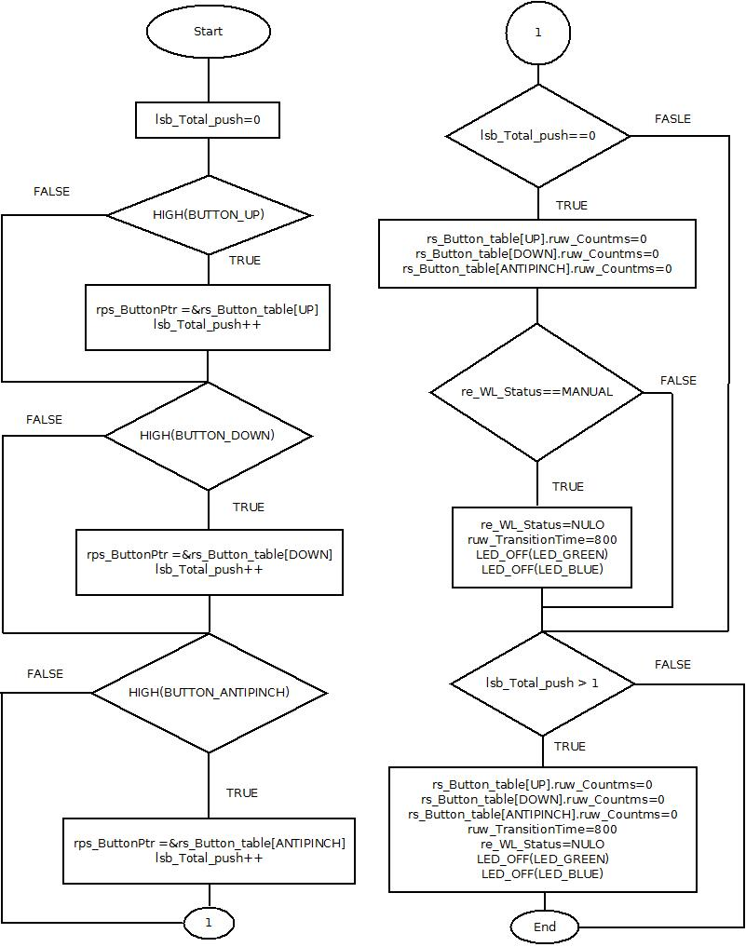

Function void dummy_Led_Response(void)

Description | This function is responsible for the secure and correct time simulation of the WL according to the Button pressed
Parameter 1 | Void
Return Value | Void
Precondition
Post condition
Error Conditions
